User Guide 7 Application to Amend a Planning Permit
Purpose of this User Guide
The purpose of this User Guide is to provide assistance to Applicant Contacts and Responsible Authorities about amending a planning permit that has been issued in SPEAR.
Who should read this?
Primary audience: Applicants and Responsible Authorities
Introduction
Once a Responsible Authority has issued a planning permit, the Applicant Contact can submit an ‘Application to Amend a Planning Permit’. The application form will be viewed and assessed by the Responsible Authority in SPEAR. The Responsible Authority may either accept or reject the application.
In accepting the application, the Responsible Authority can require further documentation and additional information to be supplied by the Applicant Contact. The Responsible Authority will also be required to re-check whether the additional advertising and/or referrals are required because of the proposed changes to the planning permit.
If the Responsible Authority accepts the amendment application, they must make an ‘Amended Planning Permit decision’ (similar to permit decision). The Responsible Authority may choose to issue a ‘Notice of Decision’ (NOD) to grant an amended planning permit, a ‘refusal’ or a ‘grant of the amended planning permit’. In the case of a NOD or refusal, the original planning permit remains valid.
If the Responsible Authority grants an ‘Amended Planning Permit’, the original permit is no longer valid and will be watermarked ‘Superseded’.

7.1 How does the Applicant Contact apply to amend a planning permit in SPEAR?
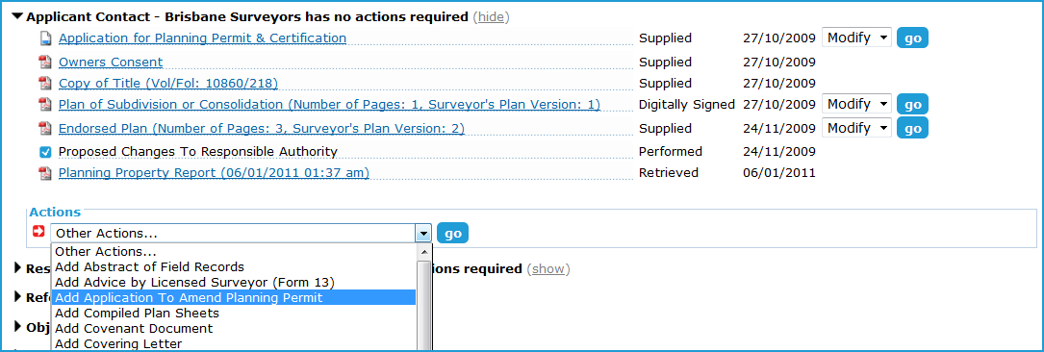
Once a planning permit has been granted in SPEAR, the Applicant Contact can apply to amend the planning permit by selecting the optional action ‘Add Application to Amend Planning Permit’ from the ‘Other Actions’ drop-down list on the Details tab.

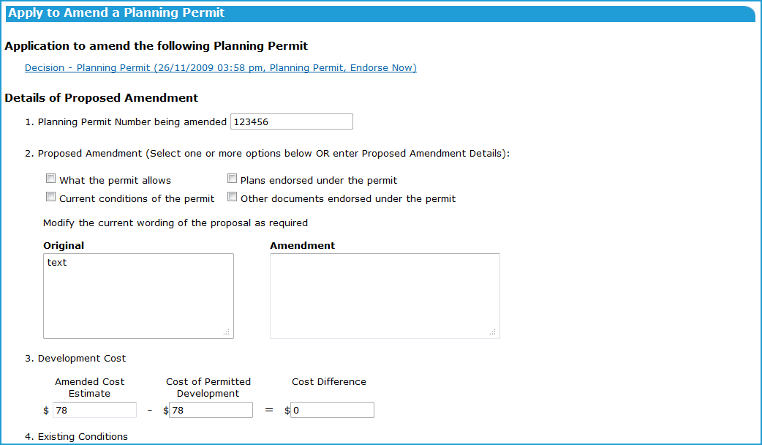
SPEAR presents a form to the user, to indicate what is being changed. Complete all relevant fields and click ‘continue’.

Once the document is authenticated, it will be saved in SPEAR and an email notification sent to the Responsible Authority notifying them of the application. SPEAR will create a mandatory action for the Responsible Authority to assess the application to amend the planning permit.

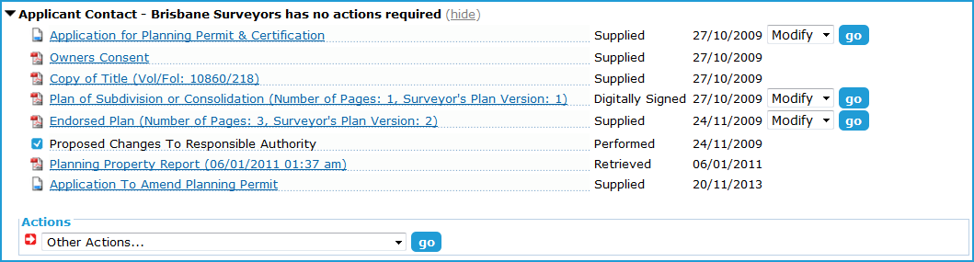
If any of the application documents, including plans and reports, also require amending, select the ‘modify’ option beside each relevant document and add a new version of each as necessary.

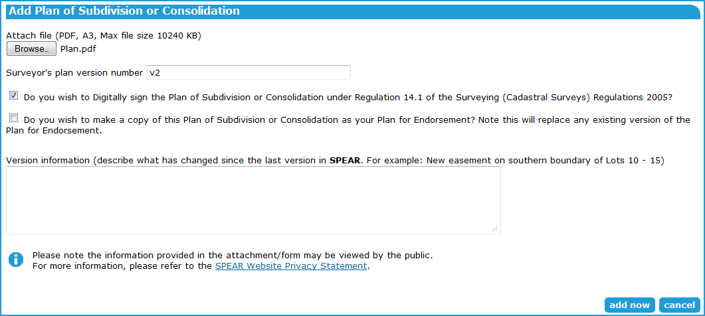
Add the new document with a description of the changes. Click ‘add now’ to continue and authenticate the document.

When the user has modified and added any new documents, click the mandatory action ‘submit all changes to Responsible Authority’ to notify them of the proposed changes. You will be required to make a declaration regarding the material being submitted.

The Responsible Authority will now have a mandatory action to assess the proposed amendments.
7.2 How does the Applicant Contact withdraw an application to amend planning permit?
If an application to amend a planning permit is no longer required before it is submitted to the Responsible Authority, it can be deleted.
Once an application to amend a planning permit has been submitted to the Responsible Authority, it can be withdrawn provided the Responsible Authority has not begun processing it.
7.3 How does the Responsible Authority assess an application to amend the planning permit / or application documents?
Once an application to amend the planning permit has been lodged through SPEAR, the Responsible Authority will have a mandatory action to ‘Assess Application to Amend Planning Permit’.
The Responsible Authority may also have the mandatory action to ‘Assess Proposed Change to Application’ if the Applicant Contact has lodged new documents or modified existing documents.
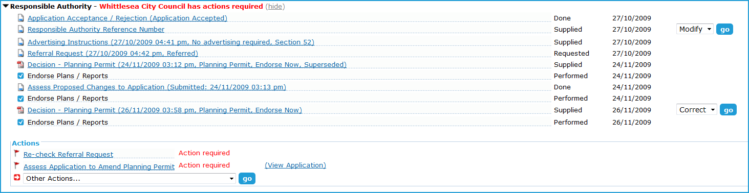

In the example above, the Applicant Contact has lodged an amendment to the planning permit and altered or added documents. If the Applicant Contact only wished to amend the permit, the Responsible Authority would have only the mandatory action to ‘Assess Application to Amend Planning Permit’.
The Responsible Authority must process each of the mandatory actions (as applicable). Click the mandatory action ‘Assess Application to Amend Planning Permit’ and select ‘accepts’, ‘accepts but requires additional documentation’, or ‘rejects the application’.

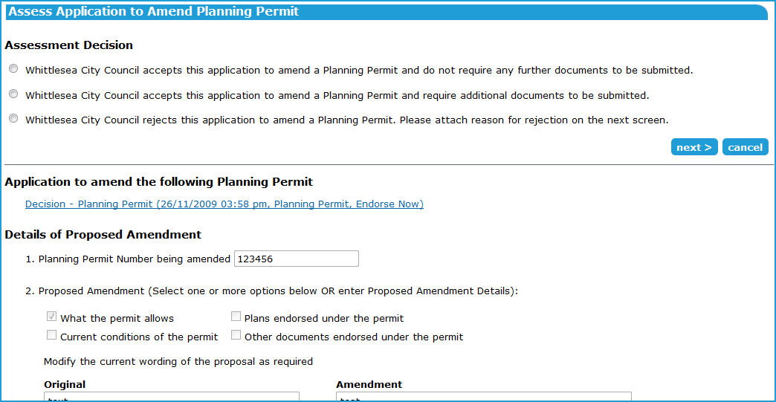

Rejecting the application will notify the Applicant Contact of the rejection and the current planning permit will remain unaffected.
If the Responsible Authority accepts the proposed amendment, the Responsible Authority user needs to authenticate the action. SPEAR will notify the Applicant Contact that the proposed amendment has been accepted and will be processed by the Responsible Authority.
NOTE: This does not infer that the Responsible Authority will support or approve the amendment.
If the Responsible Authority accepts, but requires additional documents to be submitted, the Responsible Authority will be presented with a form to specify the documents required. This will place mandatory actions on the Applicant Contact to add the documents.
When the Responsible Authority is ready to make the amended permit decision, and if the status of the application allows for it, the user will also need to indicate whether the existing certification (if certified) is impacted. If the existing certification decision is impacted, a notification will be sent to the Applicant Contact advising they may need to submit a Form 8 (Request for Re-Certification).
If the Responsible Authority rejects the proposed amendment request, the Responsible Authority user will be required to attach a document describing why the proposed amendment could not be accepted by the Responsible Authority and authenticate the action.
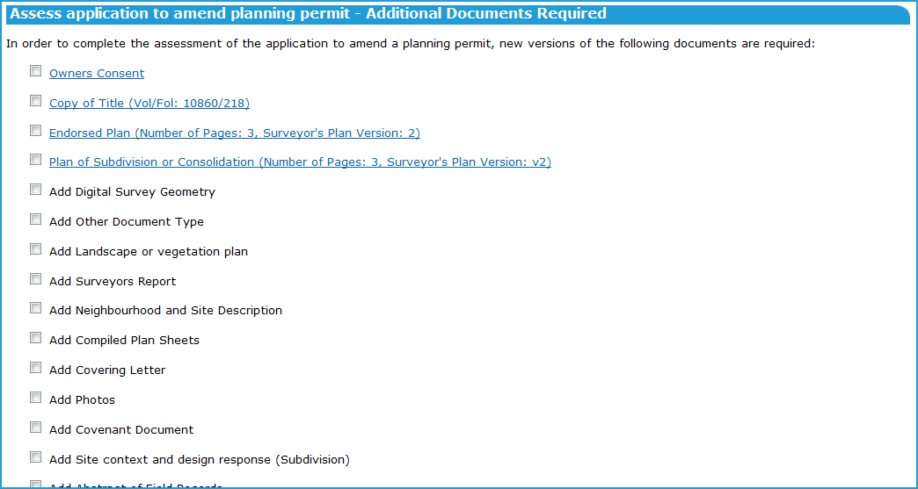
7.4 How does the Responsible Authority assess an application to amend the application documents?
When an Applicant Contact modifies or adds new documents to SPEAR, a mandatory action is placed on the Responsible Authority to ‘Assess Proposed Changes to Application’.
The Responsible Authority user must process this action, by clicking the mandatory action, viewing the added / modified plans, and choosing to either ‘Accept the proposed changes’, ‘Accept the proposed changes with additional fees’, or ‘Reject the proposed changes’.
NOTE: This does not infer that the Responsible Authority will support or approve the proposed changes.

In the example above, the Responsible Authority user needs to click on the Assess Proposed Changes to Application link and, in the example below, choose to ‘accept’, ‘accept with fees’, or ‘reject’.
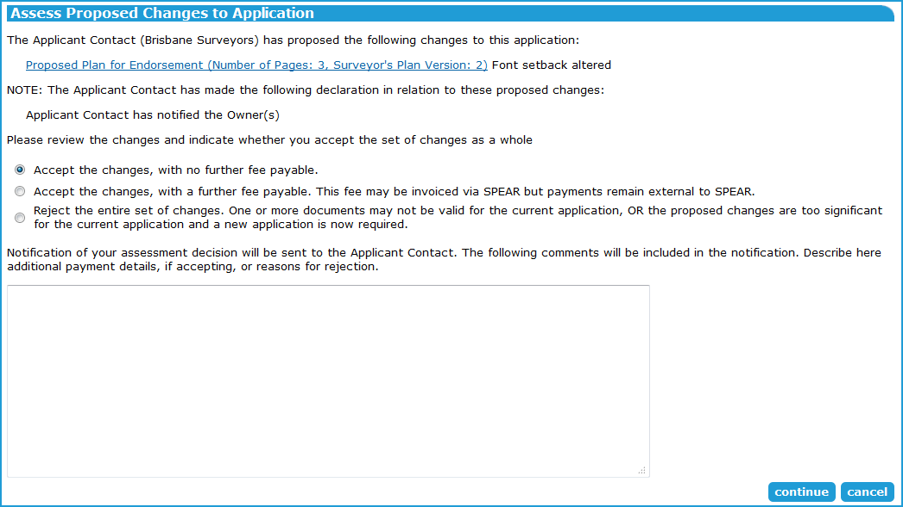

If the Responsible Authority rejects the proposed changes, the user will be required to attach a document describing why the proposed changes could not be accepted by the Responsible Authority and authenticate the action.
In all cases, the action must be authenticated by the Responsible Authority user, which notifies the Applicant Contact of the decision.
7.5 What occurs after the ‘Application to Amend Planning Permit’ and / or ‘Application to amend the application documents’ has been accepted by the Responsible Authority?
After the Responsible Authority user has accepted the proposed amendments or proposed changes / new documents, SPEAR requires the Responsible Authority to re-check the advertising and referral requirements.
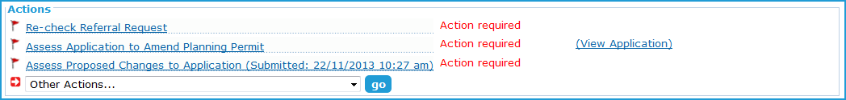
Click the mandatory action ‘Re-check Advertising Instructions’ and provide required advertising direction to the Applicant Contact. Authenticate the action to notify the Applicant Contact. See User Guide 4 for details on advertising.

Click the mandatory action ‘Re-check Referral Request’, and select any required referrals, as necessary. Authenticate the action to notify the referral authorities and Applicant Contact.
7.6 How does a Responsible Authority amend a planning permit in SPEAR?
Making an amended planning permit decision in SPEAR is the same process as the original planning permit decision with the same options (‘Grant’, ‘Refuse’ or ‘NOD’) available to the Responsible Authority. The decision must also be authenticated.

Refer to User Guide 6 for detailed instruction on issuing the planning permit and endorsing application documents.
Need more information?
Further information on this topic can be found by:
- Visiting the SPEAR website www.spear.land.vic.gov.au/SPEAR.
- Contacting the SPEAR Service Desk on 9194 0612 or email spear.info@delwp.vic.gov.au
- Selecting the Help link in the relevant area of the system.
- Referring to User Guide 6 – Issuing a Planning Decision.

